Robert Charles Ulmer
October 1, 1939 – May 23, 1955

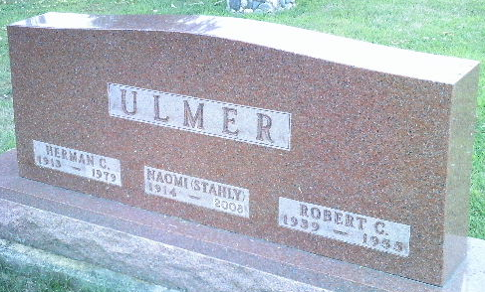
Photo by Bruce Sonner

Handwritten date: Wednesday, May 25, 1955

BLUFFTON LAD CRUSHED UNDER OVERTURNED CAR
Robert Ulmer, 14, Son of Former Naomi Stahly, Victim

Funeral services were held at 2 p.m. today at the Reformed Church in Bluffton for Robert Ulmer, 14, son of Mr. and Mrs. Herman (Hank) Ulmer, 227 West Central Avenue, Bluffton, who was injured fatally at 10:20 p.m. Monday. The youth’s mother is the former Naomi Stahly, a native of Adams County and many relatives reside in this community.
Rev. Matthew Worthman officiated at the funeral and burial was in Elm Grove Cemetery of Bluffton.
The youth was killed when he was pinned beneath an overturned car at the Toll Gate corner one mile north of Bluffton, on State Road 1. The accident happened just opposite the Habegger home who lives on the northeast corner of the intersection.
The youth, a sophomore in the Bluffton High School, suffered a broken neck and a crushed chest in the mishap and died within a few moments after fellow students reached him.
Ulmer was a passenger in a 1940 Ford coupe driven by Robert Shafer, 16-year-old son of Mr. and Mrs. John Shafer, 504 East Wiley Ave., Bluffton.

Adams County Historical Museum, Adams County, Indiana
March 1955 – April 1958 Scrapbook

**
Indiana, U.S., Death Certificates, 1899-2011
Name: Robert Charles Ulmer
Gender: Male
Race: White
Age: 15
Marital status: Never Married (Single)
Birth Date: 1 Oct 1939
Birth Place: Ind
Death Date: 23 May 1955
Death Place: Rural, Wells, Indiana, USA
Father: Herman Ulmer
Mother: Naomi Stahly
Informant: Herman Ulmer; Bluffton, Indiana
Burial: May 25, 1955; Elm Grove Cemetery; Bluffton, Indiana

