Ralph D. Ulmer
February 28, 1908 – November 12, 1972

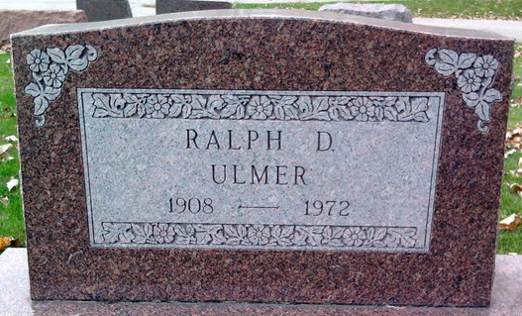
Photo by Thomas Liby

Ralph D. Ulmer, 64, died Sunday at Clinic Hospital. Mr. Ulmer operated the Linger Inn Motel for 20 years, adjacent to his residence at 703 South Main Street.
A native of Rockcreek Township, he was born February 28, 1908, a son of Charles and Josephine Simeral Ulmer. He was a lifelong resident of Wells County and a member of First United Church of Christ.
Surviving are the wife, the former Pauline Kumfer whom he married March 23, 1962; one son, Michael Ulmer of Bluffton, Route 4; one daughter, Mrs. Connie Meeks of Bluffton and three stepsons, Kenneth, Eugene and Larry Kumfer, all of Fort Wayne. Three brothers, Herman of Bluffton, Glen and Fred, both of Sturgis, Michigan; one sister, Mrs. William (Olive) Wile of Bluffton; 14 grandchildren and two great grandchildren also survive.
Services will be held at Thoma Funeral Home with burial in Elm Grove Cemetery on Tuesday.

Bluffton News-Banner, Wells County, Indiana
November 12, 1972

