Naomi M. (Stahly) Ulmer
August 24, 1914 – April 13, 2008

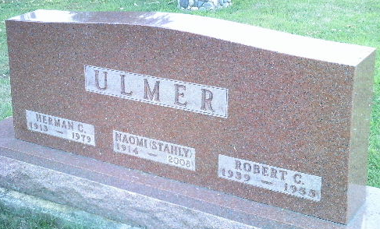
Photo by Bruce Sonner

Naomi M. Ulmer, 93, of Bluffton, died at 10 p.m. Sunday, April 13, 2008, at her residence. Born in Geneva on Aug. 21, 1914 to Jacob and Martha (Speicher) Stahly, she married Herman Ulmer in Bluffton on Nov. 26, 1936; he preceded her in death on Sept. 22, 1979.
A 1933 graduate of Hartford City High School and Fort Wayne Beauty College, Mrs. Ulmer owned and operated Naomi’s Fashions in downtown Bluffton for 20 years, and also assisted in Herman’s Market and worked as a beautician. She served as Deaconess in the First Reformed Church of Bluffton and contributed many hours of volunteer work at the Caylor-Nickel Clinic and Hospital. She was also a member and past president of Psi Iota Xi.
Surviving are a son, John D. “Jack” (Carole) Ulmer of Goshen; a daughter, DiAnn (David) Willits of Bluffton; one sister, Joan Scheckner of Chicago; five grandchildren, and 10 great-grandchildren.
Mrs. Ulmer was also preceded in death by a son, Robert, two brothers, Marcus and John Stahly, and four sisters, Mary Stahly, Hannah Archer, Elizabeth Godfrey and Esther Stahly.
Funeral services will be at 10:30 a.m. Wednesday, at the Thoma/Rich, Chaney and Lemler Funeral Home in Bluffton with Tony Garton officiating. Calling hours will be from 5 to 8 p.m. Tuesday and for one hour prior to the service at the funeral home. Burial is at Elm Grove Cemetery, in Bluffton.
Preferred memorials are to the First Reformed Church, Adams County Home Health Care or the Family Hospice of Northeast Indiana.

Thoma/Rich Funeral Home, Wells County, Indiana
April 14, 2008

**
Indiana, U.S., Death Certificates, 1899-2017
Name Naomi M Ulmer
Maiden Name Stahly
Gender Female
Race White
Age 93
Marital Status Widowed
Birth Date 24 Aug 1914
Birth Place Geneva, Indiana
Death Date 13 Apr 2008
Death Place Bluffton, Wells, Indiana, USA
Death Registration Date 2008
Father Jacob Stahly
Mother Martha Speicher
Informant DiAnn Willits, daughter
Burial Elm Grove Cemetery, no date given

