Lena A. (Woodward) Ulmer
December 5, 1875 – January 3, 1920

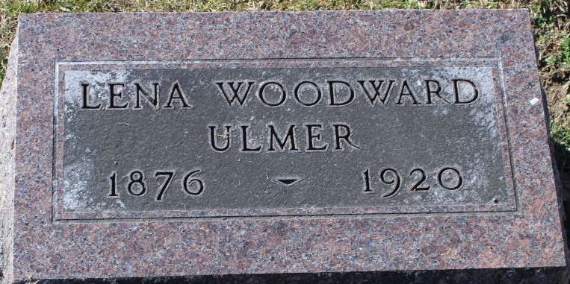
Photo by Tombstoner & Family

Mrs. Frank Ulmer Claimed by Death
Had Been Ill Several Months but Death Came in Sudden Collapse Today

Following serious sickness extending two or three months came the death about noon today of Mrs. Frank Ulmer at her home on East Central Avenue. She was one of the city's best known and highly esteemed women. Death was due to leakage of the heart and complications.
This morning Mrs. Ulmer appeared to be in about the same state of health as for some days past and her husband went to his work as usual this morning. She took a sudden change for the worst shortly before noon and Mr. Ulmer was summoned home. She passed away in a short time.
Mrs. Ulmer has been a resident of Bluffton for fourteen years, she and Mr. Ulmer, who is a clerk at the Leader Store, having established themselves high in the respect of a host of friends, who mourn deeply Mrs. Ulmer's death. Possessed with a most kindly disposition, friendly, and ever ready to lend a helping hand, Mrs. Ulmer came to be greatly endeared especially to club ladies with whom she was more intimate.
Mrs. Ulmer was a member of the Eastern Star, the K. K. Club, the Four F. Club, and the Methodist Church.
Born at Bridgeport Conn., December 5, 1875, Mrs. Lena Woodward Ulmer was the daughter of Melvin N. Woodward and Mrs. Kathryn Quinn Woodward, and at the time of death she had reached the age of 44 years and 28 days. Her marriage to Mr. Ulmer took place at Defiance, Ohio, November 6, 1906. No children were born to their union. The husband and mother survive. Mrs. Woodward having arrived two weeks ago to be at her daughter's bedside. One brother, George Woodward, is deceased.
Funeral services will be held at the house on Monday afternoon, at 2:30 o'clock, the rites being in charge of Rev. C. H. Smith. Interment will be made at the Elm Grove Cemetery.

Unknown source

**
Indiana, U.S., Death Certificates, 1899-2017
Name Lena A Ulmer
[Lena A Woodward]
Gender Female
Race White
Marital Status Married
Age 45
Birth Date (Month ?) 5, 1875
Birth Place Bridgeport Conn.
Death Date 3 Jan 1920
Death Place Bluffton, Wells, Indiana, USA
Death Registration Date 1920
Father Melvin N Woodward
Mother Katheryn Quinn
Spouse Frank Ulmer
Informant Frank Ulmer; Bluffton, Indiana
Burial January 5, 1920; Elm Grove Cemetery

