Julia A. (Hedges) Ulmer
June 11, 1854 – May 24, 1930

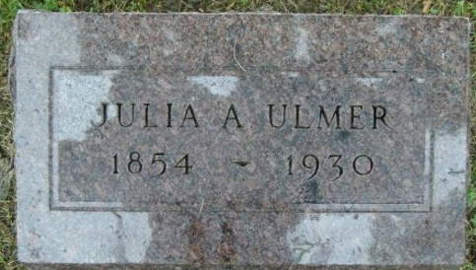
Photo by Smalltown

Mrs. Julia Ulmer's Funeral Held Today
Death Saturday Ends Long Life of Usefulness in Community
The funeral of Mrs. Julia A. Ulmer, 75, whose death occurred late Saturday, was held at 2:30 o'clock this afternoon, with services at the home of the son, Frank Ulmer, 224, East Central Avenue. The Rev. G. P. Hubbartt, pastor of the First M. E. Church, had charge of the services, and burial took place in Elm Grove Cemetery.
Death followed a period of invalidism that extended over a period of four years. She had been confined to her bed for about ten days.
Mrs. Ulmer had been a lifelong resident of Wells County and had always been held in high esteem. An especially noteworthy period of her life was the span of several years during which she and her late husband had charge of the county orphans home, conducted in a large frame farm resident that stood on the site which is today occupied by the new brick building of the Wells County Detention Home. She became a real mother in the care and attention she bestowed upon the public wards placed in her charge and was universally loved and revered, by scores of those former wards who today are grown men and women, many of them with families of their own.
She was a member of the Methodist Church.
Born in Wells County on June 11, 1854, Mrs. Ulmer was a daughter of Robert M. and Sophia Kirkwood Hedges, both deceased. Her marriage to George A. Ulmer took place in Bluffton on March 19, 1874, and most of their lives were spent on the farm. After surrendering the cares of the orphanage with advancing years, they resided for a few years at Pleasant View, a short distance south of Bluffton, before coming to Bluffton to reside with their son. Mr. Ulmer died April 19, 1922.
There were born to Mr. and Mrs. Ulmer two children, both of whom reside in this city, the son Frank, and a daughter, Mrs. Rena Huffman. There are three grandchildren, Joe and Fred Huffman and Mrs. Wendell Reed. Brothers and sisters also surviving are Mrs. James B. Gavin and Samuel Hedges of Liberty Township; James Hedges of Harrison Township; Lewis Hedges of Culver, and John Hedges of Nottingham Township.
The following seven brothers and sisters preceded Mrs. Ulmer in death: Mrs. Cinda Tuttle, Mrs. Philip Ulmer, Mrs. Jonas Hedges, Mrs. Alexander Latamore, William Hedges, Joseph Hedges and George Hedges.

Evening News Banner, Wells County, Indiana
Monday, May 26, 1930

