Hillard R. Ulmer
April 23, 1900 – July 4, 1958

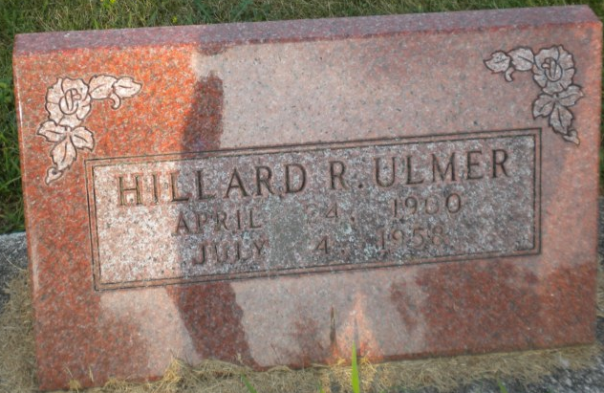
Photo by PLGS

Hillard Ulmer
in the Indiana, U.S., Death Certificates, 1899-2017
Name Hillard Ulmer
Gender Male
Race White
Marital Status Never Married (Single)
Age 58
Birth Date 23 Apr 1900
Birth Place Indiana
Death Date 4 Jul 1958
Death Place Bluffton, Wells, Indiana, USA
Death Registration Date 1958
Father Charles Ulmer
Mother Josephine Simeral
Informant Herman Ulmer; brother; Bluffton, Indiana
Burial July 6, 1958; Elm Grove Cemetery; Bluffton, Indiana

