Herman C. Ulmer
February 27, 1913 – September 22, 1979

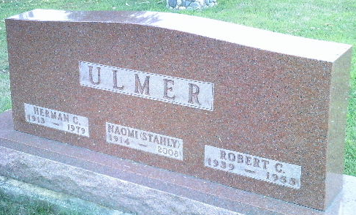
Photo by Bruce Sonner

Herman C Ulmer
in the Indiana, U.S., Death Certificates, 1899-2017
Name Herman C Ulmer
Gender Male
Race White
Marital Status Married
Age 66
Birth Date 27 Feb 1913
Birth Place Indiana
Death Date 22 Sep 1979
Death Place Bluffton, Wells, Indiana, USA
Death Registration Date 1979
Father Charles Ulmer
Mother Josephine Simeral
Spouse Naomi Stahly
Informant Naomi Ulmer; Bluffton, Indiana
Burial September 25, 1979; Elm Grove Cemetery; Bluffton, Indiana

