George Anthony Ulmer
November 5, 1852 – April 19, 1922

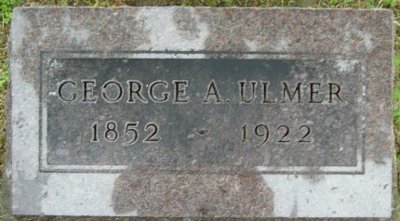
Photo by Smalltown

George Anthony Ciline
in the Indiana, U.S., Death Certificates, 1899-2017
Name George Anthony Ulmer
Gender Male
Race White
Marital Status Married
Age 69
Birth Date 5 Nov 1852
Birth Place Ohio
Death Date 19 Apr 1922
Death Place Bluffton, Wells, Indiana, USA
Death Registration Date 1922
Father John Ulmer
Mother Elizabeth Giehty
Spouse Julia Ann Hedges
Informant Family; Bluffton, Indiana
Burial Can't read

