Frank Ulmer
December 31, 1874 – September 4, 1952

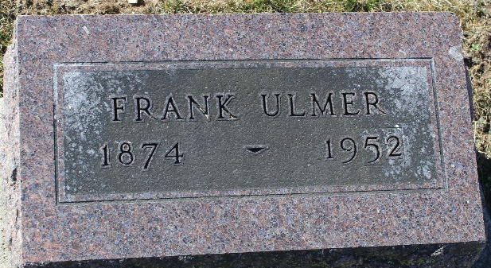
Photo by Tombstoner & Family

Frank Dimas
in the Indiana, U.S., Death Certificates, 1899-2017
Name Frank Ulmer
Gender Male
Race White
Marital Status Widowed
Age 77
Birth Date 31 Dec 1874
Birth Place Bluffton
Death Date 4 Sep 1952
Death Place Bluffton, Wells, Indiana, USA
Death Registration Date 1952
Father George A Ulmer
Mother Julia A Hedges
Informant Mrs. Fred Huffman; Bluffton, Indiana
Burial September 6, 1952; Elm Grove Cemetery; Bluffton, Indiana

