Charles Nelson Ulmer
August 31, 1869 – September 1948

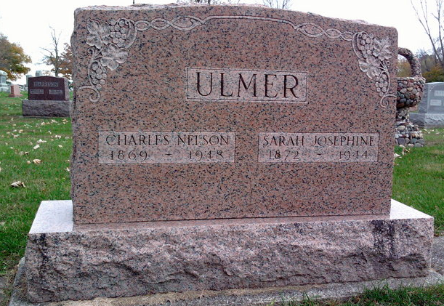
Photo by Thomas Liby

Charles Nelson Ulmer
in the Indiana, U.S., Death Certificates, 1899-2017

Name Charles Nelson Ulmer
Gender Male
Race White
Marital Status Widowed
Age 79
Birth Date 31 Aug 1869
Birth Place Wells County, Indiana
Death Date 25 Sep 1948
Death Place Bluffton, Wells, Indiana, USA
Death Registration Date 1948
Father Peter Ulmer
Mother Caroline Fulton
Spouse Sarah J Simeral; deceased
Informant Herman Ulmer; son; Bluffton, Indiana
Burial September 28, 1948; Elm Grove Cemetery; Wells County, Indiana

