Verdi M. (Decker) Ullman
January 26, 1900 – September 27, 1979

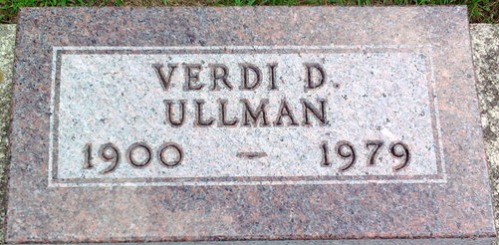
Photo by Thomas Liby

Verdi D Ullman
in the Florida, U.S., Death Index, 1877-1998
Name Verdi D Ullman
Race White
Age at Death 79
Birth Date 26 Jan 1900
Death Date 27 Sep 1979
Death Place Pinellas, Florida, United States

**
Indiana, U.S., Marriages, 1810-2001
Name Verdie M Decker
Gender Female
Race White
Age 21
Event Type Marriage Registration (Marriage)
Birth Date 26 Jan 1900
Birth Place Wells, Indiana
Marriage Date 10 Dec 1921
Marriage Place Indiana, United States
Residence Place Bluffton, Indiana
Father Charles M Decker
Mother Lillie Mcafee
Spouse Howard Marsh Ullman
Page 105

