Rebecca A. (Merklinger) Ullman
January 18, 1849 – November 28, 1937

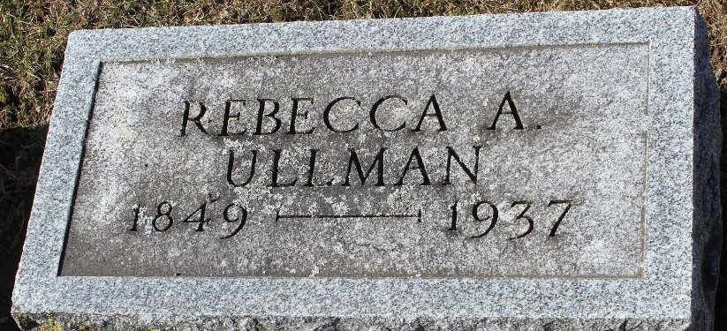
Photo by Tombstoner & Family

Rebecca Ullman
in the Indiana, U.S., Death Certificates, 1899-2017
Name Rebecca Ullman
[Rebecca Merklinger]
Gender Female
Race White
Marital Status Widowed
Age 88
Birth Date 18 Jan 1849
Birth Place Ohio
Death Date 28 Nov 1937
Death Place Bluffton, Wells, Indiana, USA
Death Registration Date 1937
Father Daniel Merklinger
Mother Margaret
Spouse Geo A Ullman
Informant Arthur Ullman; Bluffton, Indiana
Burial December 1, 1937; Elm Grove Cemetery

