Martha M. (Marsh) Ullman
April 13, 1864 – May 27, 1960

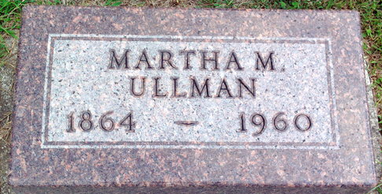
Photo by Thomas Liby

Martha Ullman
in the Indiana, U.S., Death Certificates, 1899-2017
Name Martha Ullman
[Martha Marsh]
Gender Female
Race White
Marital Status Widowed
Age 96
Birth Date 13 Apr 1864
Birth Place Ohio
Death Date 27 May 1960
Death Place Bluffton, Wells, Indiana, USA
Death Registration Date 1960
Father Charles Marsh
Mother Rosanna
Informant Howard Ullman; son; Bluffton, Indiana
Burial May 29, 1960; Elm Grove Cemetery; Bluffton, Indiana

