Howard Marsh Ullman
April 27, 1895 – October 5, 1985

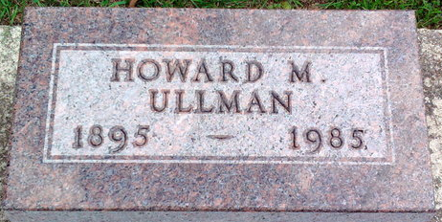
Photo by Thomas Liby

Howard M Ullman
in the U.S., Department of Veterans Affairs BIRLS Death File, 1850-2010
Name Howard M Ullman
Gender Male
Birth Date 27 Apr 1895
Death Date 5 Oct 1985
SSN xxx
Enlistment Date 26 Jun 1918
Discharge Date 30 Sep 1921
Page number 1
**
Indiana, U.S., Marriage Certificates, 1960-2012
Name Howard Marsh Ullman
Gender Male
Race White
Marriage Age 26
Birth Date 27 Apr 1895
Birth Place Ashland, Ohio
Marriage License Date 10 Dec 1921
Marriage Date 10 Dec 1921
Marriage Place Wells, Indiana, USA
Residence Place Bluffton, Indiana
Father Joseph A Ullman
Mother Martha Marsh
Spouse Verdie M Decker
Officiator W A Alspach

