George A. Ullman
December 27, 1847 – January 28, 1919

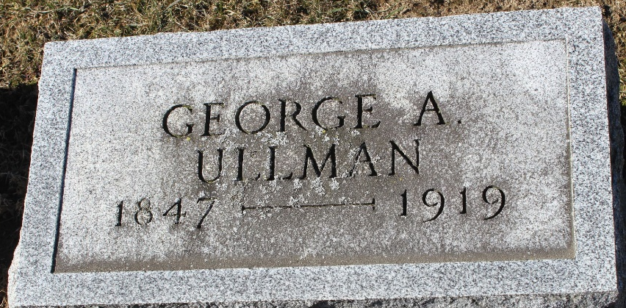
Photo by Tombstoner & Family

George A Ullman
in the Indiana, U.S., Death Certificates, 1899-2017
Name George A Ullman
Gender Male
Race White
Marital Status Married
Age 71
Birth Date 27 Dec 1847
Birth Place Loudowville. Ohio
Death Date 28 Jan 1919
Death Place Bluffton, Wells, Indiana, USA
Death Registration Date 1919
Father Adam Ullman
Mother Barbra Lambert
Spouse Rebecia A
Informant Family; Bluffton, Indiana
Burial January 31, 1919; Elm Grove Cemetery

