Dorothy A. (Simmons) Ullman
January 14, 1928 – December 6, 1983

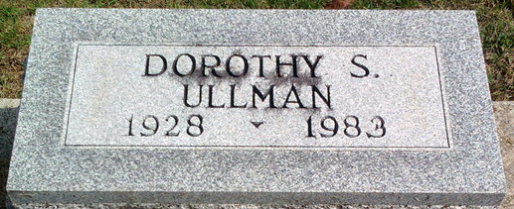
Photo by Thomas Liby

Dorothy S. Ullman
in the Indiana, U.S., Death Certificates, 1899-2017
Name Dorothy S. Ullman
[Dorothy S. Simmons]
Gender Female
Race White
Marital Status Divorced
Age 55
Birth Date 14 Jan 1928
Birth Place Indiana
Death Date 6 Dec 1983
Death Place Bluffton, Wells, Indiana, USA
Death Registration Date 1983
Father Joseph Simmons
Mother Mary Markley
Informant Daniel Ullman; Bluffton, Indiana
Burial December 9, 1983; Elm Grove Cemetery; Bluffton, Indiana

