Arthur Paul Ullman
July 5, 1881 – January 1, 1941

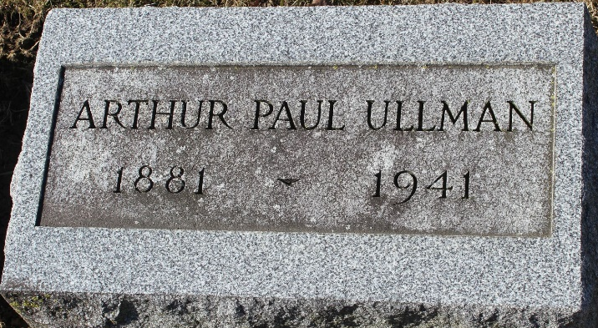
Photo by Tombstoner & Family

Arthur Paul Ullman
in the Indiana, U.S., Death Certificates, 1899-2017
Name Arthur Paul Ullman
Gender Male
Race White
Marital Status Single
Age 59
Birth Date 5 Jul 1881
Birth Place Ashland, Ohio
Death Date 1 Jan 1941
Death Place Bluffton, Wells, Indiana, USA
Death Registration Date 1941
Father George A Ullman
Mother Rebecca Merklinger
Informant Mrs. Anna Crites; Bluffton, Indiana
Burial January 3, 1941; Elm Grove Cemetery; Bluffton, Indiana

