Madonna L. (DeBois) Bergdoll-Uhrick
October 28, 1928 – August 27, 2001

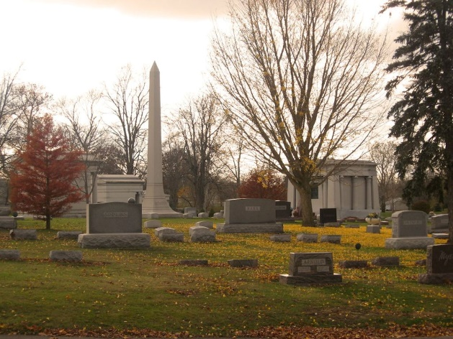
Photo by Tombstoner & Family

Madonna L. Uhrick, 72, of Bluffton, died Monday, Aug. 27, 2001, at Lutheran Hospital in Fort Wayne. She was born Oct. 28, 1928, in Hartford City, the daughter of James D. and Emma A. Daniels DuBois. She had lived in Bluffton since 1949 and was a member of Calvary Lutheran Church there.
Survivors include her husband, Elmer Uhrick, and one local survivor, a son, James O. Bergdoll of Madison.
Services will be at 10:30 a.m. Wednesday at Goodwin Memorial Chapel in Bluffton, with burial in Elm Grove Cemetery in that city.
Friends may call from 2 to 8 p.m. today at the chapel.
Expressions of sympathy may take the form of contributions to the Diabetes and Heart Association.

Madison Courier, Jefferson County, Indiana
August 28, 2001

**
Indiana, Death Certificates, 1899-2011

Name: Madonna L Uhrick
[Madonna L Dubois]
Gender: Female
Race: White
Age: 72
Marital status: Married
Birth Date: 28 Oct 1928
Birth Place: Hartford City, In
Death Date: 27 Aug 2001
Death Place: Ft Wayne, Allen, Indiana, USA
Father: James D Dubois
Mother: Emma A. Daniels
Spouse: Elmer Uhrick
Informant: Elmer Uhrick; husband; Bluffton, Indiana
Burial: August 29, 2001; Elm Grove Cemetery; Bluffton, Indiana

