Fred W. Uebelhoer
November 24, 1887 – September 24, 1937

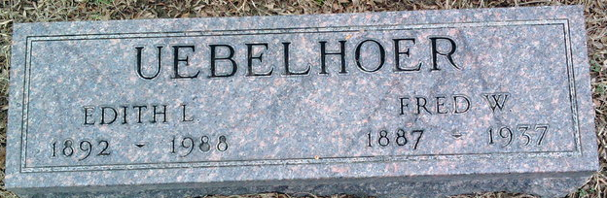
Photo by Thomas Liby

Fred W Uebelhoer
in the Indiana, U.S., Death Certificates, 1899-2017
Name Fred W Uebelhoer
Gender Male
Race White
Marital Status Married
Age 49
Birth Date 24 Nov 1887
Birth Place Fort Wayne, Indiana
Death Date 24 Sep 1937
Death Place Fort Wayne, Allen, Indiana, USA
Death Registration Date 1937
Father John Uebelhoer
Mother Rose Wendt
Spouse Edith
Informant Edith Oebelhoer
Burial September 27, 1937; Bluffton, Indiana

