Edith L. (Carrysot) Uebelhoer
February 14, 1892 – November 19, 1988

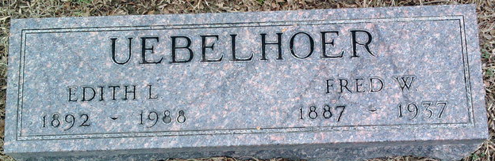
Photo by Thomas Liby

Edith L Uebelhoer
in the Indiana, U.S., Death Certificates, 1899-2017
Name Edith L Uebelhoer
[Edith L Carrysot]
Gender Female
Race White
Marital Status Widowed
Age 96
Birth Date 14 Feb 1892
Birth Place Wells County, Indiana
Death Date 19 Nov 1988
Death Place Fort Wayne, Allen, Indiana, USA
Death Registration Date 1988
Father Adolphus Carrysot
Mother Samantha Febuary
Informant Wendell Dowty; Ossian, Indiana
Burial November 22, 1988; Elm Grove Cemetery; Bluffton, Indiana

