Mary Alice (Macklin) Tyndall-Gallman
January 11, 1907 – March 27, 1986

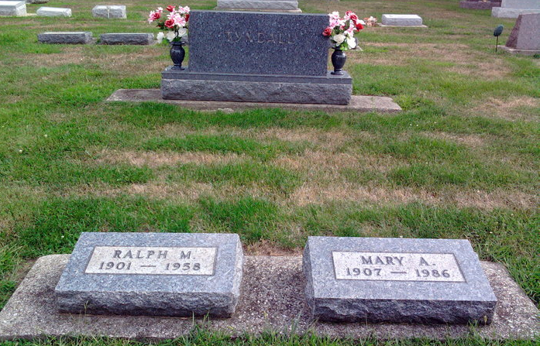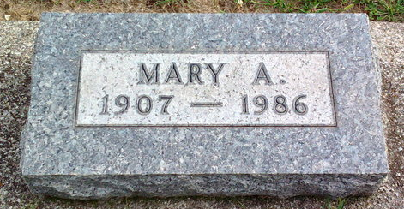
Photo by Thomas Liby

Mary A Gallman
in the Indiana, Death Certificates, 1899-2011
Name: Mary A Gallman
[Mary A Macklin]
Gender: Female
Race: White
Age: 79
Marital Status: Married
Birth Date: 11 Jan 1907
Birth Place: Indiana
Death Date: 27 Mar 1986
Death Place: Bluffton, Wells, Indiana, USA
Father: Phillip Macklin
Mother: Lola Jackson
Informant: Phillip Tyndall; son; Fort Wayne, Ind.
Burial: March 31, 1986; Elm Grove Cem., Bluffton, Ind.

