Artha O. (Kline) Turner
April 3, 1909 – January 22, 1972

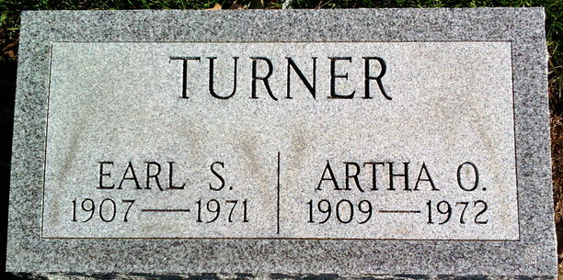
Photo by Thomas Liby

Mrs. Artha Turner, 62, of Bluffton, widow of Earl S. Turner died today at Wells Community Hospital. Born April 3, 1909 in Noble County, she was a daughter of Frank and Grace Abrams Kline. Her marriage to Mr. Turner, who died April 13, 1971, took place at Camden, Ohio on April 22, 1927.
Surviving are a son, Jon E. of Bluffton and a twin brother, Art Kline of Pontiac, Michigan.
Funeral services will be held Monday at Thoma Funeral Home; burial will be in Elm Grove Cemetery.

Bluffton News-Banner, Wells County, Indiana
January 22, 1972

**
Indiana, U.S., Death Certificates, 1899-2017
Name Artha O Turner
[Artha O Kline]
Gender Female
Race White
Marital Status Widowed
Age 62
Birth Date 3 Apr 1909
Birth Place Indiana
Death Date 22 Jan 1972
Death Place Bluffton, Wells, Indiana, USA
Death Registration Date 1972
Father Frank Kline
Mother Grace Abrams
Informant Jon Turner; son; Bluffton, Indiana
Burial January 24, 1972; Elm Grove Cemetery; Bluffton, Indiana

