Martha A. (Reece) Trullender
August 4, 1915 – August 4, 1983

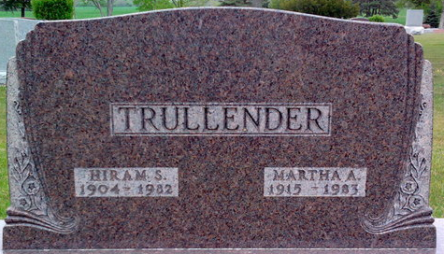
Photo by Thomas Liby

Martha A. Trullender
in the Indiana, U.S., Death Certificates, 1899-2017
Name Martha A. Trullender
[Martha A. Reece]
Gender Female
Race White
Marital Status Widowed
Age 68
Birth Date 4 Aug 1915
Birth Place Indiana
Death Date 4 Aug 1983
Death Place Tocsin, Wells, Indiana, USA
Death Registration Date 1983
Father Palmer Reece
Mother Amanda Poling
Informant Mary Smith; daughter; Tocsin, Indiana
Burial August 7, 1983; Elm Grove Cemetery; Bluffton, Indiana

