Jules N. Toussaint
December 6, 1903 – July 17, 1983

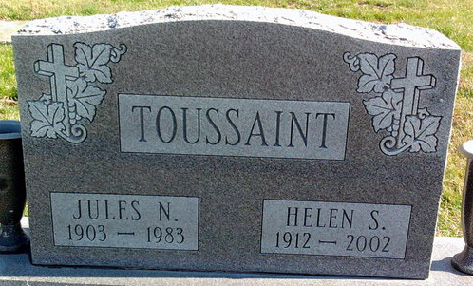
Photo by Thomas Liby

Jules N. Toussaint
in the Indiana, U.S., Death Certificates, 1899-2017
Name Jules N. Toussaint
Gender Male
Race White
Marital Status Married
Age 79
Birth Date 6 Dec 1903
Birth Place Indiana
Death Date 17 Jul 1983
Death Place Fort Wayne, Allen, Indiana, USA
Death Registration Date 1983
Father Joseph Toussaint
Mother Julie Miller
Spouse Helen S.
Informant Helen S. Toussaint; Fort Wayne, Indiana
Burial July 20, 1983; Elm Grove Cemetery; Bluffton, Indiana

