Sylvan Andrew Tonner
October 3, 1896 – June 3, 1950

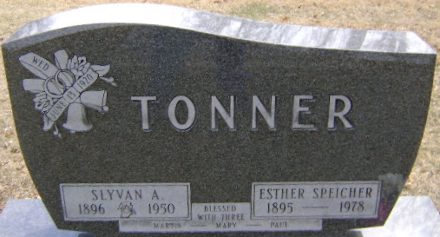
Photo by Bruce Sonner

Death • Ohio, Deaths, 1908-1953

Sylven Andrew Tonner
Name Sylven Andrew Tonner
Sex Male
Age 53
Birth Date 3 Oct 1896
Birthplace Indiana
Race White
Father's Name John Tonner
Father's Sex Male
Mother's Name Mary
Mother's Sex Female
Event Type Death
Event Date 3 Jun 1950; airplane accident
Event Place Bedford Township, Cuyahoga, Ohio, United States
Event Place (Original) Bedford Twp, Cuyahoga
Informant Daniel Berry
Burial June 5, 1950; Elm Grove Cemetery; Bluffton, Indiana
Reference certificate

**
Sylvan Andrew Tonner in Postier Family Tree

Spouse Delores Hey
Father John Tonner
Mother Mary Ann Lobsiger
Children Mary Elizabeth
Birth 3 Oct 1896 Adams, Indiana, USA
Death 3 Jun 1950 Williams, Ohio, USA
Residence 1900 Adams, Indiana, USA

