Annette M. (Wilmore) Thill
August 16, 1946 – November 7, 2011

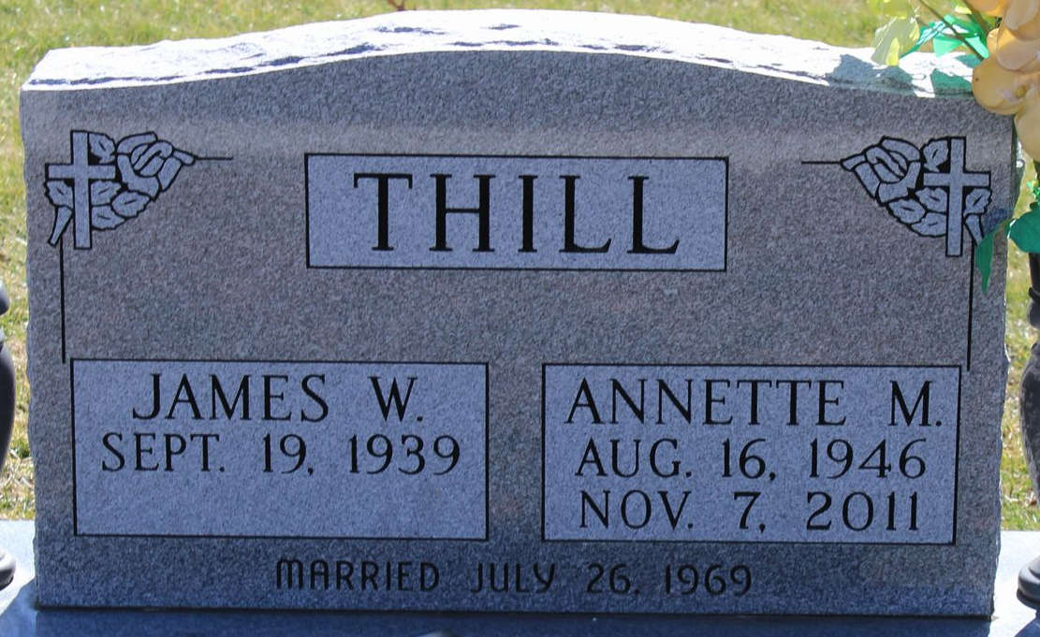
Photo by Tombstoner & Family

Annette M. Thill, 65, of Bluffton, passed away at 9:16 a.m. Monday, Nov. 7, 2011, at the Bluffton Regional Medical Center.
Mrs. Thill was an X-ray technician for the Caylor-Nickel Clinic for 15 years, and then at Jay County Hospital for 20 years, before she retired in July of this year. She was a graduate of Dunkirk High School. She enjoyed quilting.
She was born Aug. 16, 1946, in Portland, to George Wilmore and Ann Hiles Wilmore; her mother survives in Dunkirk. She married James W. Thill July 26, 1969, in Dunkirk; her husband survives in Bluffton.
Also surviving are two sons, Jeff (Robin) Thill of Orlando, Fla., and Ken (Kristie) Thill of Redondo Beach, Calif.; a daughter, Jenny (Dave) Hunter of Decatur; six grandchildren, Tyler Thill, Bethanie Thill, Michael Thill, Matthew Thill, Devon Hunter, and Jace Hunter; three brothers, Michael (Mineko) Wilmore of Austin, Texas, George (Mary) Wilmore of Garrett, and Greg Wilmore of Dunkirk; and a sister, Karen (Edgar) Williams of Dunkirk.
She was preceded in death by her father and a brother, Brian Wilmore.
Calling will be from 2 to 8 p.m. Thursday, Nov. 10, and from 9:30 to 10:30 a.m. Friday, Nov. 11, at the Goodwin Memorial Chapel. Services will be held at the Goodwin Memorial Chapel at 10:30 a.m. Friday with Pastor Roy Nevil officiating. Burial will be at the Elm Grove Cemetery.
Preferred memorials are to the Wounded Warrior Project.

Goodwin Funeral Home, Wells County, Indiana
November 8, 2011

