Spencer Lee Teague
December 27, 1990 – July 20, 2020

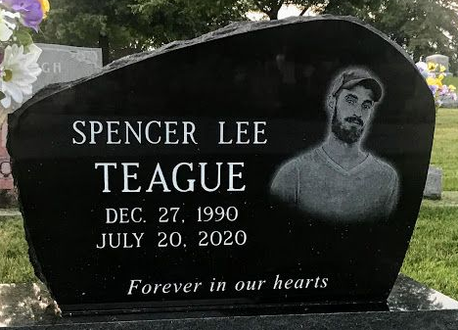
Photo by SMMR

Spencer Teague, 29, of Keystone, passed away on Monday, July 20, 2020 at his residence. He was born on December 27, 1990 in Bluffton to Steve Teague and Patti (Penrod) Teague-Osborn. He graduated from Southern Wells High School with the class of 2010.
Spencer could be described as a tinkerer. He loved to take things apart just to see how they worked and enjoyed the challenge of seeing if he could put it back together again! He also enjoyed working on cars and kayaking. Spencer worked at Honest Automotive in Bluffton, Mark Bryant Construction and for Mitch Maddox, where he worked and cleaned pools.
Spencer is survived by his father, Steve (Jody) Teague, mother, Patti (Todd) Osborn, along with his children: Kaeson Teague, Blaine Teague and Kenzie Townsend. He is also survived by his siblings: Anna (Chase) Adams, Johnathan Osborn, Suzanne (Brad) Smith, Travis Osborn, Austin Osborn and his companion, Bre Miller, along with his grandparents: Joanna Penrod, Patricia Teague, Lynn & Carol Osborn, Ed & Judy Kramer and Kenny & Sharon Kirtley and many other extended family members.
He is preceded in death by two grandpa’s, Jerry Penrod and Jewell Teague.
Calling hours will be held from 2 to 8 P.M. on Thursday, (July 23, 2020) at the Thoma/Rich, Lemler Funeral Home in Bluffton and for one hour prior to the service. A Service to celebrate Spencer’s life will be held at 10:30 A.M. on Friday, (July 24, 2020) at the funeral home with Pastor Troy Drayer officiating. Burial will follow at Elm Grove Cemetery in Bluffton.
Memorials may be made to the family for Spencer’s children’s educational fund.
The safety of the family and all visitors are our utmost priority. For everyone’s safety, we ask that you practice social distancing and a mask is recommended during your visit. We appreciate your cooperation and patience.

Thoma/Rich Funeral Home, Wells County, Indiana
July 22, 2020

