Carol Jean (Riggenbach) Tarr
September 8, 1933 – July 31, 2010

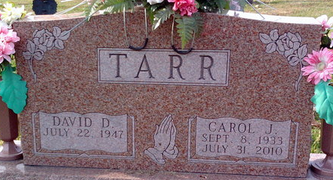
Photo by Thomas Liby

Carol Jean Tarr 76 of Bluffton passed away at 7:50 a.m. Saturday, July 31, 2010 at the Hospice Home in Fort Wayne, Indiana. Carol was born on September 8, 1933 in Paulding County, Ohio to Elmer and Sarah 'Sadie' Anna (Stoller) Riggenbach.
She attended Oakwood High School in Oakwood, Ohio. She was married to Robert G. Steffen on July 26, 1953 who precedes her in death on October 6, 1999. On October 4, 1980 in Bluffton she married David D. Tarr. They have been married for the last 30 years.
Along with taking care of her family as a homemaker, Carol also worked for some time at Wayne Candies in Fort Wayne, the Davis Nursing Home and in the offices at Almco Steel and Franklin Electric in Bluffton. She was a very active member of Community Christian Church where she taught Sunday School for many years.
Survivors include her husband David of Bluffton, six children: Randall (Dian) Steffen of Fort Wayne, Craig (Jean) Steffen of Ossian, Mrs. Kent (Amy) Worthman of Bluffton, Duane (Karen) Steffen of Bluffton, Mitchell (Tess) Steffen of Fort Wayne, Mrs. Rex (Vivian) Drennen of Montpelier, along with a brother Clarence Riggenbach of Venice, Florida, along with three sisters: Mrs. Jim (Florence) Treece of Florence, Alabama, Mrs. Wilbur (Lila) Miller of Port Charlotte, Florida and Mrs. Ramon (Lorena) Steffen of Bluffton. She is also survived by 19 grandchildren and 14 great-grandchildren. She is preceded in death by her parents; a son, Kelly Brian; seven brothers: infant Orville, Elmer Jr., Everett, Mervin, Ersel, Vern and Glen Riggenbach; and four sisters: Eleanor Tope, Arlene Carnahan, Melvine Zink and Myrna Moser.
Calling hours will be held from 2 to 8 p.m. on Tuesday, August 3, 2010 at the Thoma/Rich, Chaney & Lemler Funeral Home in Bluffton. Funeral services will be held at 11:00 a.m. Wednesday, August 4, 2010 at Community Christian Church with calling 1 hour prior to the service. Pastor Wayne Ball and Dr. Gene Bell will officiate. Burial will follow at Elm Grove Cemetery in Bluffton.
Memorials may be made in Carol's memory to Community Christian Church.

Thoma/Rich Funeral Home, Wells County, Indiana
August 1, 2010

