Richard Ross Swisher
January 8, 1926 – November 6, 1977

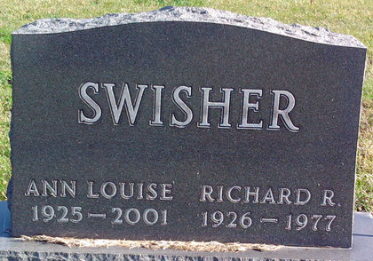
Photo by Thomas Liby

Richard Rose Swisher
in the Indiana, U.S., Birth Certificates, 1907-1944
Name Richard Ross Swisher
Gender Male
Birth Date 8 Jan 1926
Birth Place Bluffton, Wells, Indiana, USA
Father George A. Swisher; age 29
Mother Lois Gaunt; age 25; 2nd child; both living
Certificate Number 5264
Roll number 40474_357755
Volume Range 11 - 15

**
Indiana, U.S., Death Certificates, 1899-2017
Name Richard R. Swisher
Gender Male
Race White
Marital Status Married
Age 51
Birth Date 8 Jan 1926
Birth Place Indiana
Death Date 6 Nov 1977
Death Place Indianapolis, Marion, Indiana, USA
Death Registration Date 1977
Father George Swisher
Mother Not named
Informant Ann Swisher; wife; Bluffton, Indiana
Burial November 9, 1977; Elm Grove Cemetery; Bluffton, Indiana

