Lois Jane (Gaunt) Swisher
August 12, 1900 – May 24, 1948

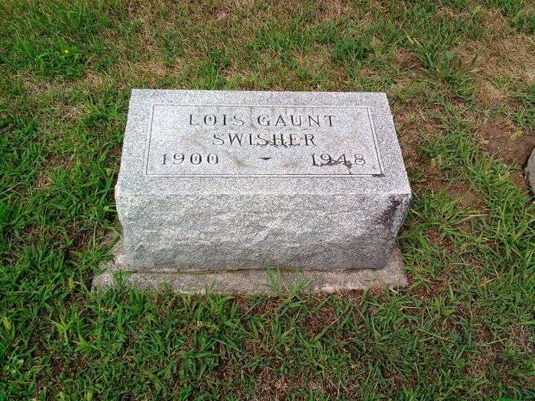
Photo by Thomas Liby

Lois Jane Janet Swisher
in the Indiana, U.S., Death Certificates, 1899-2017
Name Lois Jane Gaunt Swisher
[Lois Jane Gaunt]
Gender Female
Race White
Marital Status Married
Age 47
Birth Date 12 Aug 1900
Birth Place Cedarville, Ohio
Death Date 24 May 1948
Death Place Bluffton, Wells, Indiana, USA
Death Registration Date 1948
Father Alpheus B Gaunt
Mother Rebecca Jane Ross
Spouse George Alexander Swisher; age 50
Informant George Swisher
Burial May 26, 1948; Elm Grove Cemetery; Wells County, Indiana

