Ann Louise (Schlotzhauer) Swisher
May 27, 1925 – August 17, 2001

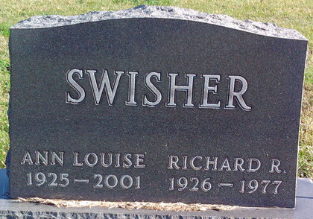
Photo by Thomas Liby

Ann Louise Swisher
in the North Carolina, U.S., Death Indexes, 1908-2004
Name Ann Louise Swisher
[Ann Louise Schlotzhauer]
Gender Female
Race White
Hispanic Origin Non-Hispanic
Marital Status Widowed
Age 76
Birth Date 27 May 1925
Birth Place Indiana, USA
Residence Place Other, Beaufort, Indiana
Residence Zip Code 46714
Education 12th grade
Death Date 17 Aug 2001
Hospital Name Rex Health Care Center
Death Place Raleigh, Wake, North Carolina
Social Security Number xxx
Father's Last Name Schlotzhauer
Source Vendor North Carolina State Center for Health Statistics
Notes Disposition: Removal out-of-state, Autopsy: Autopsy Not Performed, Attendant: Physician, Findings: Autopsy findings were not considered in determining cause of death, Hospital Status: Hospital Inpatient
**
U.S., Social Security Applications and Claims Index, 1936-2007
Name Ann Louise Schlotzhauer
[Ann Lou Swisher]
[Anna Swisher]
Gender Female
Race White
Birth Date 27 May 1925
Birth Place Bluffton Wel, Indiana
Death Date 17 Aug 2001
Father Milton E Schlotzhauer
Mother Hilda W Schlotzhauer
SSN xxx
Notes Jun 1943: Name listed as ANN LOUISE SCHLOTZHAUER; Sep 1948: Name listed as ANN LOU SWISHER; 22 Aug 2001: Name listed as ANNA L SWISHER

