Sabrina Jo Stotlar
August 9, 1967 – August 24, 1968

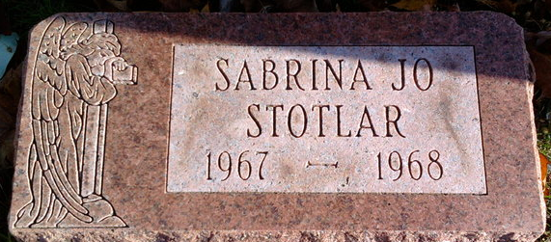
Photo by Thomas Liby

Subrina Jo Stotlar
in the Indiana, U.S., Death Certificates, 1899-2017
Name Sabrina Jo Stotlar
Gender Female
Race White
Marital Status Never Married (Single)
Age 1 year, 15 days
Birth Date 9 Aug 1967
Birth Place Indiana
Death Date 24 Aug 1968
Death Place Poneto, Wells, Indiana, USA
Death Registration Date 1968
Father William Stotlar
Mother Phyllis Jo Piety
Informant William Stotlar; father; Poneto, Indiana
Burial August 24, 1968; Elm Grove Cemetery; Bluffton, Indiana

