Robert William Stine
March 7, 1866 – May 6, 1944

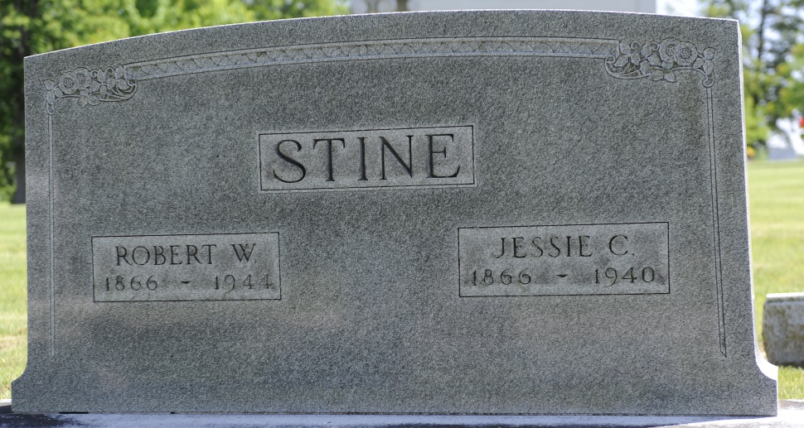
Photo by Thomas Liby

Robert William Stine
in the Indiana, U.S., Death Certificates, 1899-2017
Name Robert William Stine
Gender Male
Race White
Marital Status Widowed
Age 78
Birth Date 7 Mar 1866
Birth Place Carrol Co, Ohio
Death Date 6 May 1944
Death Place Bluffton, Wells, Indiana, USA
Death Registration Date 1944
Father David Stine
Mother Mary Seaton
Spouse Jessie Clyde Swaim
Informant Mrs. O. E. Lesh
Burial May 8, 1944; Elm Grove Cemetery; Bluffton, Indiana

