William J. Stewart
June 25, 1925 – July 12, 1999

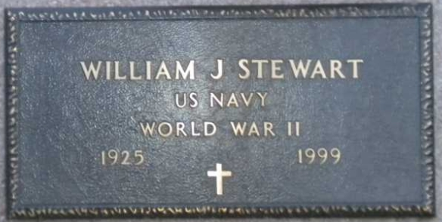
Photo by Tombstoner & Family

William J. Stewart
in the Indiana, U.S., Death Certificates, 1899-2017
Name William J. Stewart
Gender Male
Race White
Marital Status Married
Age 74
Birth Date 25 Jun 1925
Birth Place Amsterdam, New York
Death Date 12 Jul 1999
Death Place Fort Wayne, Allen, Indiana, USA
Death Registration Date 1999
Father Robert J. Stewart
Mother Anna McGaffen
Spouse Martha Jane Clark
Informant Martha Jane Stewart; Spouse; St. Marys, Ohio
Burial July 16, 1999; Elm Grove Cemetery; Bluffton, Indiana

