Dr. C. David Steury
September 15, 1946 – December 15, 2001

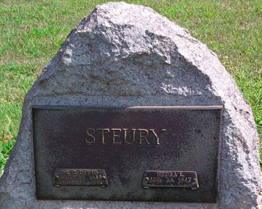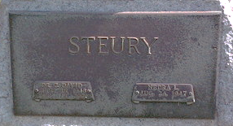
Photo by Thomas Liby

Dr. C David Steury, 55, died Saturday at this home. Born in Adams County, he had been a physician at Caylor Nickel Medical Center now Bluffton Regional Medical Center, since 1982. He was also a high school teacher for five years in Garrett-Keyser-Butler schools. He and his wife also taught at the American School, Bogota, Columbia.
He was named physician of the year in 1985, was past president of the medical staff, clinic board and a current member of the American College of Gastroenterology.
Surviving are his wife, Nedra; his parents, Clinton and Ruth Steury of Fort Wayne; a son, James W. of Cecil, Ohio; a daughter, Courtney A Steury of Indianapolis; a brother, Wesley of Fort Wayne; and two sisters, Ann Tomlinson of Merrimack, NH, and Rhoda Culbertson of Fort Wayne.
Services at 10:30 am Thursday at First Presbyterian Church, Bluffton. Calling from 7 to 9 pm Tuesday and from 2 to 8 pm Wednesday at the Thoma/Rich, Hewitt & Chaney Funeral Home, Bluffton. Burial in Elm Grove Cemetery.

Thoma/Rich Funeral Home, Wells County, Indiana
December 16, 2001

**
Indiana, U.S., Death Certificates, 1899-2017
Name C David Steury
Gender Male
Race American
Marital Status Married
Age 55
Birth Date 15 Sep 1946
Birth Place Adams County, Indiana
Death Date 15 Dec 2001
Death Place Bluffton, Wells, Indiana, USA
Death Registration Date 2001
Father Clinton D Steury
Mother Ruth J Muselman
Spouse Nedra Brookmyer
Informant Nedra Steury; wife; Bluffton, Indiana
Burial December 20, 2001; Elm Grove Cemetery; Bluffton, Indiana

