Willis W. Steffen
December 22, 1928 – December 13, 2009

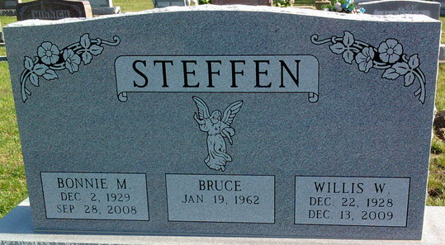
Photo by Thomas Liby
Willis W. Steffen, 80, of Bluffton, died at 12:34 a.m. Sunday, Dec. 13, 2009, at the Bluffton Regional Medical Center. Mr. Steffen was a self-employed mechanical contractor and owned a rental business.
He was born Dec. 22, 1928, in Paulding, Ohio, to Cornelius Steffen and Anna Oberlander.
Survivors include three sons, Terry (Lynn) Steffen of Merced, Calif., Kevin (Beverly) Steffen of Bluffton, and Bruce Steffen of Morton, Ill.; a daughter, Judith Wilson of Bluffton; six grandchildren and 13 great-grandchildren; a brother, George (Wanda) Steffen of Bluffton; and two sisters, Anna Stauffer and Lillian Arnold, both of Bluffton.
He was preceded in death by a sister, Kate Nicholson, and two brothers, Norman Steffen and Ray Steffen.
Calling will be from 2 to 8 p.m. Wednesday and from 1 to 3 p.m. Thursday at the Goodwin Memorial Chapel in Bluffton. Services will be held at 3 p.m. Thursday at the funeral home with Rev. James Poling officiating. Burial will be at the Elm Grove Cemetery.
Preferred memorials are to the Timber Ridge Apostolic Christian Home in Morton, Ill.

Goodwin-Cale & Harnish Memorial Chapel, Wells County, Indiana

**
Indiana, U.S., Death Certificates, 1899-2017
Name Willis W Steffen
Gender Male; Race White
Marital Status Divorced
Age 80
Birth Date 22 Dec 1928
Birth Place Paulding, Ohio
Death Date 13 Dec 2009
Death Place Bluffton, Wells, Indiana, USA
Death Registration Date 2009
Father Cornelius Steffen
Mother Anna Oberlander
Informant Kevin Steffen; son; Bluffton, Indiana
Burial Elm Grove Cemetery; Bluffton, Indiana

