William Starr
March 16, 1843 – May 18, 1909

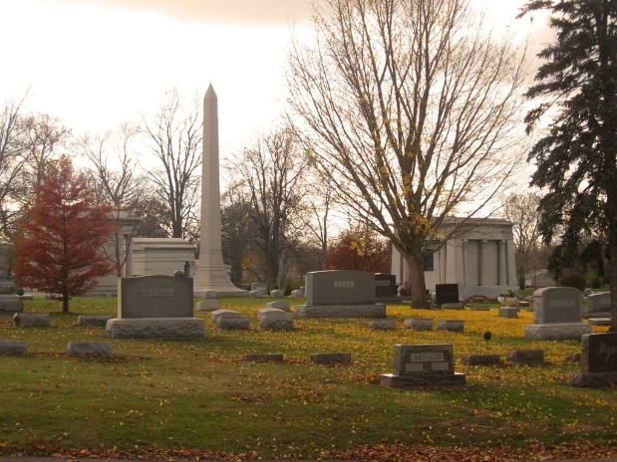
Photo by Tombstoner & Family

Willam Starr
in the Indiana, U.S., Death Certificates, 1899-2017
Name Willam Starr
Gender Male
Race White
Marital Status Divorced
Age 66
Birth Date 16 Mar 1843
Birth Place Bluffton, Indiana
Death Date 18 May 1909
Death Place Bluffton, Wells, Indiana, USA
Death Registration Date 1909
Father Engle Starr
Mother Catherine Hustleton
Informant L. G. Starr; Bluffton, Indiana
Burial May 20, 1909; Elm Grove Cemetery

