George Kenneth Smith
October 21, 1899 – November 19, 1899

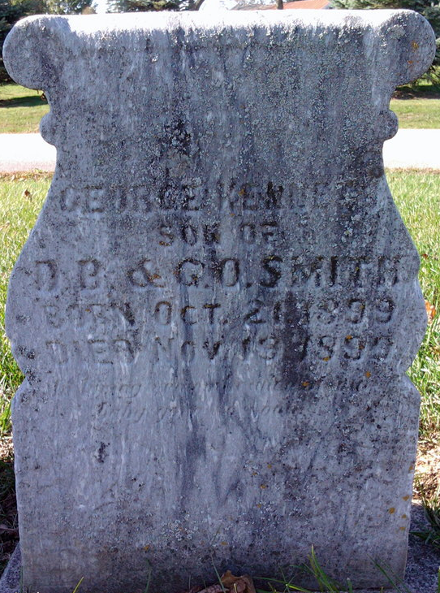
Photo by Thomas Liby

George Kenneth Smith in tree Caskey Family Tree
Father Daniel Braten Smith
Mother Gertha Olive Rinear
Birth 21 Oct 1899 Liberty Center, Wells, Indiana, USA
Death 19 Nov 1899 Liberty Center, Wells, Indiana, USA

