Ethel (Allen) Smallman-Wilder
May 30, 1910 – January 21, 1992

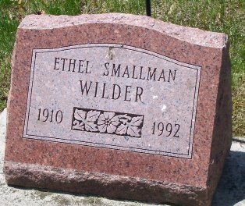
Photo by Thomas Liby

MRS. ETHEL SMALLMAN WILDER, DIES TUESDAY AT AGE OF 81

A resident of Bluffton the past 4 1/2 years, Mrs. Ethel Smallman Wilder, 81, of 518 East Horton St., died at 11:40 a.m. Tuesday at Wells Community Hospital.
Born May 30, 1910 in LaFollette, Tenn., she was a daughter of Charles and Della Shelby Allen. Her first marriage Feb. 15, 1925 in Grays, Ky., was to Joe T. Smallman, who preceded her in death Nov. 15, 1968. A second marriage to Abe Wilder, who died Sept. 16, 1979, took place Sept. 16, 1972 in Caloway, Ky.
Mrs. Wilder was a member of Brown's Creek Baptist Church.
Surviving are three sons, Everett Smallman and Carl Smallman, both of Bluffton, and Joe T. Smallman Jr., of Carmel; her mother, Mrs. Della Allen of LaFollette; a step-brother, Jim Allen of LaFollette; nine grandchildren and ten great-grandchildren.
Friends may call from 2 to 9 p.m. Thursday at Goodwin Chapel, where services will be conducted by Rev. Irvin Middlebusher at 1:30 p.m. Friday.
Burial will take place in Elm Grove Cemetery.

Bluffton News-Banner, Wells County, Indiana
January 22, 1992

**
Ethel Smallman Wilder, 81, of Bluffton died yesterday in Wells Community Hospital. She was the widow of Joe Smallman, who died in 1968, and Abe Wilder, who died in 1979.
Surviving are sons, Everett Smallman and Carl Smallman, both of Bluffton, and Joe T. Smallman Jr. of Carmel; a stepbrother, Jim Allen of LaFollette, Tenn.; nine grandchildren; and 10 great-grandchildren.

News-Sentinel, Allen County, Indiana
Wednesday, January 22, 1992

**
Indiana, U.S., Death Certificates, 1899-2017
Name Ethel Wilder
[Ethel Allen]
Gender Female
Race White
Marital Status Widowed
Age 81
Birth Date 30 May 1910
Birth Place LaFollette, Tennessee
Death Date 21 Jan 1992
Death Place Bluffton, Wells, Indiana, USA
Death Registration Date 1992
Father Charles Allen
Mother Della Shelby
Spouse Abe Wilder; deceased
Informant Everett Smallman; son; Bluffton, Indiana
Burial January 24, 1992; Elm Grove Cemetery; Bluffton, Indiana

