Kevin Michael Sliger
December 4, 1977 – October 8, 1982

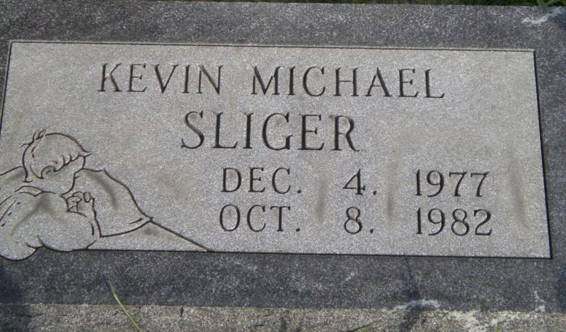
Photo by PLGS

Kevin Michael Sliger
in the Indiana, U.S., Death Certificates, 1899-2017
Name Kevin Michael Sliger
Gender Male
Race Caucasian (White)
Marital Status Single
Age 4
Birth Date 4 Dec 1977
Birth Place Indiana
Death Date 8 Oct 1982
Death Place Bluffton, Wells, Indiana, USA
Death Registration Date 1982
Father Gary Sliger
Mother Kathleen Walsh
Informant Gary Sliger; father; Bluffton, Indiana
Burial October 11, 1982; Elm Grove Cemetery; Bluffton, Indiana

