Jesse G. Sills
April 13, 1901 – July 22, 1969

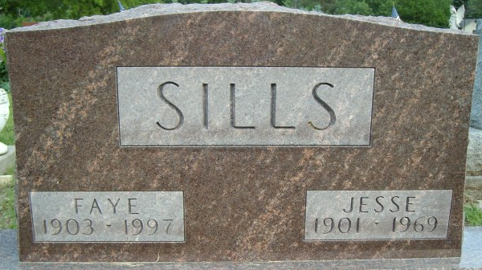
Photo by Smalltown

Jesse G. Sills, 68, died in his sleep today at his home at 315 North Morgan Street. Born in Wells County, April 13, 1901, the son of Albert and Ethel King Sills. His marriage to Faye Huffman, who survives took place in Wells County on December 24, 1921.
A lifetime resident of Wells County, Mr. Sills was retired and a member of the First United Methodist Church.
Surviving, in addition to the wife are one son, Jerry of Columbus; three brothers, Russell, Cletus and Claude, all of Bluffton, and three grandchildren. Another son, Jesse G. Sills Jr., was killed in action in World War II as a pilot in 1945.
Thoma Funeral Home is in charge with services to be held there on Thursday. Burial will be in Elm Grove Cemetery.

Bluffton News-Banner, Wells County, Indiana
July 22, 1969

**
Indiana, U.S., Death Certificates, 1899-2017
Name Jesse G Sills
Gender Male
Race White
Age 68
Marital Status Married
Birth Date 13 April 1901
Birth Place Indiana
Death Date 22 Jul 1969
Death Place Bluffton, Wells, Indiana, USA
Death Registration Date 1969
Father Albert Sills
Mother Ethel King
Spouse Faye Huffman
Informant Faye Sills; wife; Bluffton, Indiana
Burial July 24, 1969; Elm Grove Cemetery; Bluffton, Indiana

