David Shively
April 9, 1873 – June 5, 1930

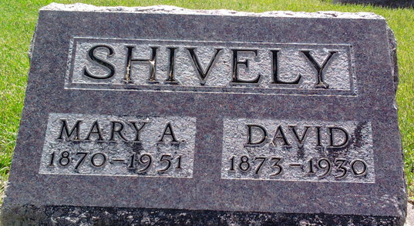
Photo by Thomas Liby

David Shirely
in the Indiana, U.S., Death Certificates, 1899-2017
Name David Shively
Gender Male
Race White
Marital Status Married
Age 57
Birth Date 9 Apr 1873
Birth Place Auglaize Co., Ohio
Death Date 5 Jun 1930
Death Place Bluffton, Wells, Indiana, USA
Death Registration Date 1930
Father John Shively
Mother Mahala Biglow
Spouse Mary Horner
Informant Mrs. David Shively; Bluffton, Indiana
Burial June 7, 1930; Elm Grove Cemetery

