Wilbur Harold Shaft
March 11, 1888 – June 11, 1968

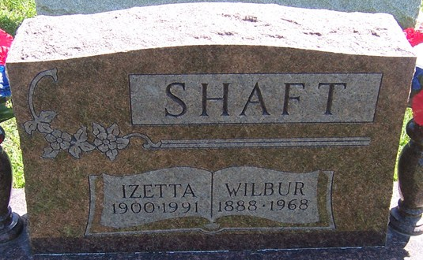
Photo by PLGS

Wilbur H. Shaft, 80, of Craigville Route 1 died Tuesday at the Cooper Rest Home in Bluffton. A resident of Wells County for 37 years, he was born March 11, 1888 to George P. and Della Reed Shaft. His marriage to Izetta Cobb, who survives, took place December 25, 1922 in Riverside, California.
A retired farmer and veteran of World War I, and a member of Lancaster Chapel United Methodist Church.
Surviving in addition to the wife are one son, Harold A. of Bluffton; four sisters, Mrs. A. F. (Cecile) Dickey of Yucca Valley, California, Mrs. E. W. (Nina) Martin of Riverside, California, Mrs. A. W. (Pearl) Peugh of Eureka, California, and Mrs. E. M. (Maude) Waldron of Fort Fairfield, Maine; two grandchildren, one step grandchild and two great grandchildren.
The McBride Funeral Home is in charge with services there on Friday, burial in Elm Grove Cemetery.

Bluffton News-Banner, Wells County, Indiana
June 12, 1968

**
Indiana, U.S., Death Certificates, 1899-2017
Name Wilbur Harold Shaft
Gender Male
Race White
Age 80
Marital Status Married
Birth Date 3 Mar 1888
Birth Place Indiana
Death Date 11 Jun 1968
Death Place Bluffton, Wells, Indiana, USA
Death Registration Date 1968
Father George P Shaft
Mother Della Reed
Spouse Izetta Cobb
Informant Mrs. Izetta Shaft; wife; Craigville, Indiana
Burial June 14, 1968; Elm Grove Cemetery; Bluffton, Indiana

