John Andon Shaffer
December 8, 1875 – February 5, 1946

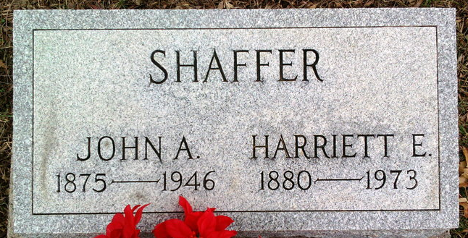
Photo by Tombstoner & Family

John Andon Shaffer
in the Indiana, U.S., Death Certificates, 1899-2017
Name John Andon Shaffer
Gender Male
Race White
Age 70
Marital Status Married
Birth Date 8 Dec 1875
Birth Place Wells Co Indiana
Death Date 5 Feb 1946
Death Place Fort Wayne, Allen, Indiana, USA
Death Registration Date 1946
Father Lemuel Shaffer
Mother Unknown
Spouse Harriett; age 65 years
Informant Mrs. Harriett Shaffer; Fort Wayne, Indiana
Burial February 8, 1946; Elm Grove Cemetery; Bluffton, Indiana

