Roscoe E. Shady
October 11, 1895 – September 12, 1954

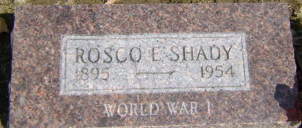
Photo by Bruce Sonner

Roscoe E Shady
in the Indiana, U.S., Death Certificates, 1899-2017
Name Roscoe E Shady
Gender Male
Race White
Age 58
Marital Status Never Married (Single)
Birth Date 11 Oct 1895
Birth Place Indiana
Death Date 12 Sep 1954
Death Place Bluffton, Wells, Indiana, USA
Death Registration Date 1954
Father Curt Shady
Mother Ellen Richey
Informant Hospital records
Burial September 14, 1954; Elm Grove Cemetery

