Phyllis Ann (Farling) Shady
April 24, 1940 – April 20, 2020

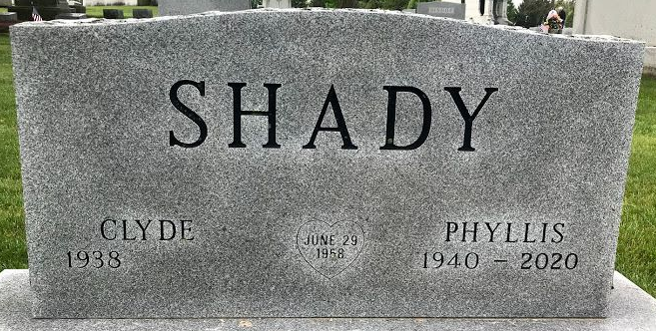
Photo by SMMR

Phyllis Ann Shady, 79 of Bluffton, passed away on Monday morning, April 20, 2020, at Christian Care Retirement Community.
Phyllis was born on April 24, 1940 in Bluffton to Harold & Anna Louise (Larrimer) Farling.
She was a 1958 graduate of Bluffton High School. A homemaker, Phyllis worked as a childcare provider and worked alongside her husband Clyde in the supermarket. She also worked for Home Health Care for various companies.
Phyllis was a member of Tri Kappa, where she belonged as an active and associate membership chapter. She was an active member of the First Baptist Church in Bluffton.
Phyllis and Clyde L. Shady were married on June 29, 1958 at the First Baptist Church.
Survivors include her husband of 61 years, Clyde of Bluffton and her children; Kent (Deb) Shady of Bluffton, Kendra Shady of Jeffersonville, Kurt (Jennifer) Shady of Milford, MA. Phyllis is also survived by 4 grandchildren; Glen (Jessica) Shady, Craig (Shelby) Shady, Isabella Shady and Jasper Shady and 5 great-grandchildren: Elizabeth Shady, Hannah Shady, Claire Shady, Maddie Shady and Crosley Shady and a brother, Larry (Karolyna) Farling of Bluffton.
Private Family services will be held at the Thoma/Rich, Lemler Funeral Home in Bluffton with her grandsons, Craig Shady and Glen Shady and Pastor Les Cantrell officiating. Burial will follow at Elm Grove Cemetery in Bluffton. Memorials may be made to First Baptist Church in Bluffton or French Christian Mission.
A public Celebration of Life service will be held at a later date.

Thoma/Rich Funeral Home, Wells County, Indiana
Tuesday, April 21, 2020

