Clarcie M. (Johnston) Shady
June 25, 1896 – May 19, 1974

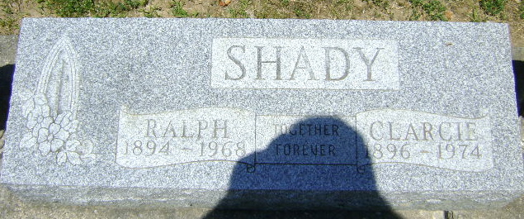
Photo by Bruce Sonner

MRS. RALPH SHADY DIES AT AGE OF 77

A resident of Tocsin until two years ago, Mrs. Ralph (Clarcie J.) Shady, 77, died at 7:45 p.m. Sunday at Whitley County Hospital in Columbia City, where she had been a patient two days. The past two years she had made her home with a daughter, Mrs. Roscoe (Alice) Linthicum of South Whitley.
Born June 25, 1896 in Adams County, she was a son [sic]) of John and Rosa Diehl Johnstone [sic]. Her marriage to Mr. Shady, who died in 1968, took place Nov. 16, 1913.
Mrs. Shady was a member of the Tocsin United Methodist Church.
Other survivors include another daughter, Mrs. Calvin (Rema) McKean of Decatur; three sons, Rev. Edgar J. Shady of McClure, O., Rev. James C. Shady of Heath, O., and Harold R. Shady of Fort Wayne; two brothers, L. F. Uhrick of Fort Wayne and Ernest Uhrick of LaGrange; two sisters, Mrs. Emma Myers and Mrs. Ellen Klusman, both of Decatur, 18 grandchildren and 24 great-grandchildren.
Calling will be after 7 p.m. today at the Elzey Funeral Home in Ossian until noon Wednesday, at which time the body will be taken to the Tocsin United Methodist Church for services at 2 p.m. in charge of Rev. Bruce Kenline. Burial will be in Elm Grove Cemetery at Bluffton.

Bluffton News-Banner, Wells County, Indiana
May 20, 1974
**

Clarcie J. Shady dies at hospital

Clarcie J. Shady, 77, a former resident of Tocsin, died at 7:45 p.m. Sunday at the Whitley county hospital, where she had been a patient two days.
She was a member of the Tocsin United Methodist church.
Born in Adams county on June 25, 1896, she was a daughter of John and Rosa Diehl-Johnstone (sic), and was married on Nov. 16, 1913 to Ralph Shady, who died in 1968.
Surviving are five children, Rev. Edgar J. of McClure, O.; Rev. James C. of Heath, O.; Harold R. of Fort Wayne; Mrs. Calvin (Rema) McKean of route 4, Decatur; Mrs. Roscoe (Alice) Linthicum of route 2, South Whitley; two brothers, L. F. Uhrick of Ft. Wayne; Ernest Uhrick of LaGrange; two sisters, Mrs. Emma Myers of Decatur; Mrs. Ellen Klusman of Decatur; 18 grandchildren and 24 great-grandchildren.
Funeral services will be held at 2 p.m. Wednesday at the Tocsin United Methodist church, with Rev. Bruce Kenline officiating. Burial will be in the Elm Grove cemetery. Friends may call at the Elzey funeral home, Ossian, after 7 p.m. tonight.

Decatur Daily Democrat, Adams County, Indiana
Monday, 20 May 1974

