Bertha May (Miller) Shady
October 18, 1879 – November 23, 1955

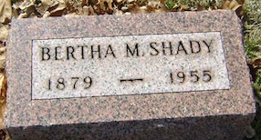
Photo by Bruce Sonner

Bertha May Shady
in the Indiana, U.S., Death Certificates, 1899-2017
Name Bertha May Shady
[Bertha May Miller]
Gender Female
Race White
Age 76
Marital Status Widowed
Birth Date 18 Oct 1879
Birth Place Indiana
Death Date 23 Nov 1955
Death Place Rural, Wells, Indiana, USA
Death Registration Date 1955
Father William Miller
Mother Mary Clawser
Informant Brooks Shady; Bluffton, Indiana
Burial November 26, 1955; Elm Grove Cemetery; Bluffton, Indiana

