Earl S. Settle
February 7, 1908 – December 2, 1972

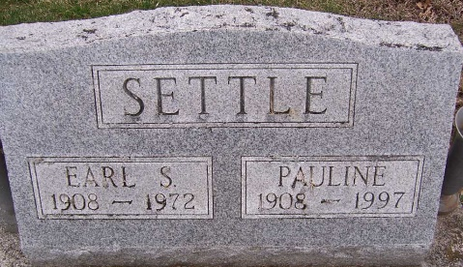
Photo by PLGS

Earl S. Settle, 64, of 813 South Jersey Street died at his home Saturday. A son of W. H. & Eva Lockwood Settle, he was born February 7, 1908 in Nottingham Township. His marriage to Pauline Bader, who survives, took place September 8, 1945 in Indianapolis.
A lifetime resident of Wells County, Mr. Settle was owner and operator of the Enco Service Station on South Main Street from 1954 until 1971.
Surviving in addition to the wife are a son, Jerry of Bluffton; a daughter, Mrs. Edmund (Justine) Dudek of St. Charles, Illinois; a brother, Huber Settle of Columbia City; a sister, Mrs. Homer (Iva) Gehrett of Indianapolis, and seven grandchildren.
Thoma Funeral Home is in charge with services to be held there Tuesday; burial in Elm Grove Cemetery.

Bluffton News-Banner, Wells County, Indiana
December 3, 1972

