John R. Schwartz
June 4, 1892 – October 8, 1977

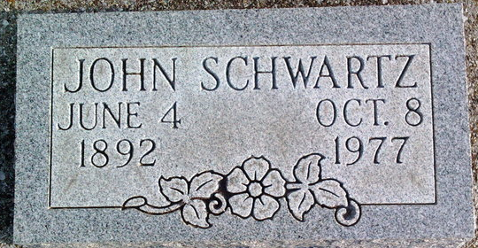
Photo by Thomas Liby

John R. Schwartz
in the Indiana, U.S., Death Certificates, 1899-2017
Name John R. Schwartz
Gender Male
Race White
Age 85
Marital Status Divorced
Birth Date 4 Jun 1892
Birth Place Indiana
Death Date 8 Oct 1977
Death Place Bluffton, Wells, Indiana, USA
Death Registration Date 1977
Father Daniel Schwartz
Mother Anna Aschliman
Informant Mrs. Donald (Delores) King; daughter; Fort Wayne, Indiana
Burial October 11, 1977; Elm Grove Cemetery; Bluffton, Indiana

